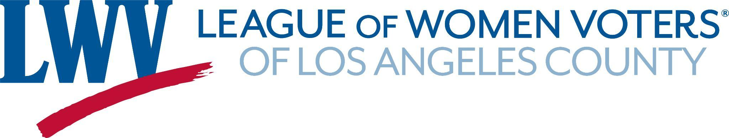

February 18, 2022

The Los Angeles County Board of Supervisors has consistently responded to the needs of our many communities and has worked to improve the lives of Los Angeles County’s residents. The League of Women Voters of Los Angeles County looks to the Board to ensure a Sheriff’s Department committed to the safety of all residents in Los Angeles County; a department that the public can trust and respect.[1]

Reform efforts by the Department and oversight bodies have not succeeded in eliminating deputy gangs. Sheriff Villanueva has denied the existence of deputy gangs, claiming that they are harmless fraternities. He has defied subpoenas and ignored transparency and oversight. This illustrates how existing County structures are insufficient to guard against sheriffs who are hostile to civilian oversight, transparency, and accountability. We urge the Board to take action to address these problems.

Suggested reforms which could be implemented immediately:

**• Reinforce the Board’s authority to create policies for LASD and delegate initial policy development to the COC**.

The Board has the duty under state law to supervise its sheriffs “in order to ensure that they faithfully perform their duties,”1 and local law recognizes that this responsibility includes the authority to direct and approve the development of policy for LASD.[2] Yet, the Board has rarely exercised this authority and, as a result, sheriffs have adopted and maintained policies that directly contravene the letter and spirit of various local, state, and federal laws.

**• Establish more robust civilian oversight of LASD.**

Strengthen the Civilian Complaint Process and the Oversight Commission. Provide the COC with independent counsel and funding commensurate with its duties, and ensure membership of community members directly impacted by LASD and the criminal legal system.

The League of Women Voters holds many public policy positions and uses its voice to advocate for the marginalized and disenfranchised. Our California League’s positions on Criminal Justice include calls to:

● Build public trust and positive community relationships through police engagement with community members.

● Provide police accountability via independent citizen oversight of law enforcement and publicly available data on officer conduct.

The League of Women Voters of Los Angeles County urges you to address this long running corruption within the Sheriff’s Department. By implementing these reforms, the fatal use of force by law enforcement officers could be significantly reduced and the responsiveness of the Department to community needs would be increased.

Thank you,

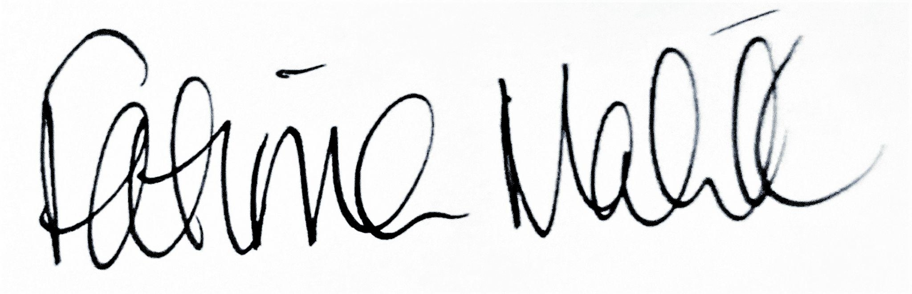

Fatima Malik, President

League of Women Voters of Los Angeles County

(2 pages enclosed/attached)

1. Dibb v. Cnty. of San Diego, 8 Cal.4th 1200, 1208-09 (Cal. 1994); Cal. Gov. Code § 25303.
2. See Los Angeles County Code § 2.06.130.